Static Timing Analysis

Exam

Please leave the rest of this page blank for use by the graders:

Problem | No. of points | Score | Grader
1 | 30
2 | 30
3 | 40
Total | 100

Problem 1 (30%)

Check whether there are setup/hold violations for the given circuit. Input signal waveform and circuit parameters are given.

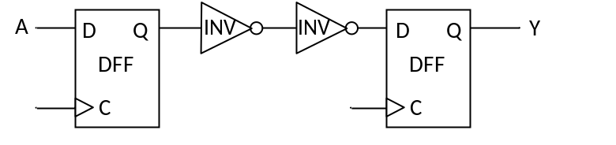

A
t(ns)
0
9
15
Parameter | Value
t_{setup,DFF} | 2ns
t_{hold,DFF} | 2.3ns
t_{cq,DFF} | 1.9ns
t_{INV} | 1.2ns
f_{Clock} | 150MHz

NAME:_________________________________
Work Page for Problem 1
Problem 2 (30%)

What is the maximum frequency (in MHz) for the following circuit? What are the constraints to avoid setup/hold violations for the given circuit?
Parameter | Value
t_{setup,DFF} | 3ns
t_{hold,DFF} | 1.5ns
t_{cq,DFF} | 2ns
t_{AND} | 1.8ns
t_{INV} | 1.2ns

DFF
C
D Q
DFF
AND2
Clock
B

NAME:_________________________________
Work Page for Problem 2

Problem 3 (40%)

Find the maximum frequency of the given circuit for these parameters:
  - t1=450ps; t2=350ps; t3=120ps
  - t1=250ps; t2=900ps; t3=210ps
C
D Q
C
D Q
C
D Q
C
D Q
t1
t2
t3
clk

NAME:_________________________________
Work Page for Problem 3

